Lab 2: Q Factor

## Explanation of Experimental Setup

In my setup I used fishing sinkers attached to a string as the mass. I taped multiple weights together to minimize interactions between them so that they would act as closely to a point mass as possible. Since following equations and relationships are modeled after point masses, it was ideal. Then, the string was tied to a ring which allowed it to oscillate while the ring remained stationary. I attempted to minimize as much friction and resistance between the string and the pivot point as possible. Increased resistance would lead to greater loss of energy between oscillations. Thus, minimizing the surface area that pivots about the ring reduced the decay of energy. Both the string and the mass had adjustable lengths and weights respectively. Another point about the pivot is that it was secured to minimize movement. A protractor was taped against the wall which allowed me to verify the results from Tracker.

From the perspective of Figure 2, I filmed the motion of the pendulum and used the program, Tracker, to analyze the motion of the mass (see Appendix). Tracker was able to determine amplitude and time. The books on each side were measured to be 0.300 m apart. They allowed me to line up the mass to the correct starting amplitude and helped to create a reference for Tracker. Finally, Q was measured against the plane of Figure 2.

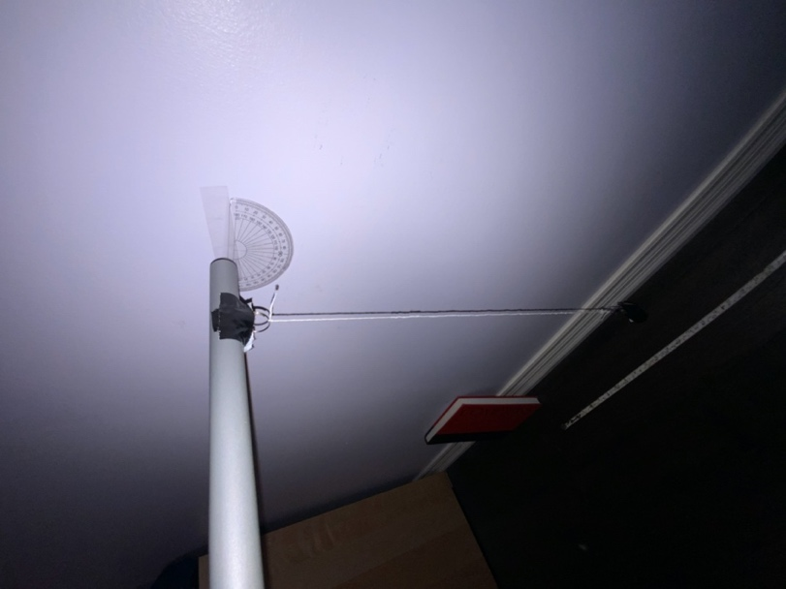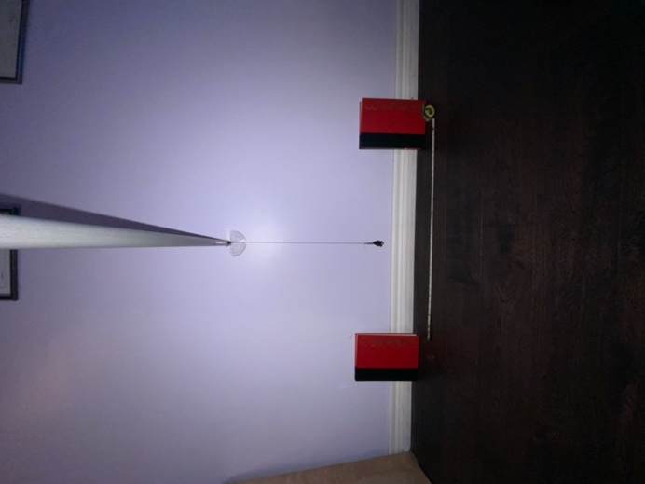

Figure 1 & 2 Images of Pendulum Setup

## Error Analysis

There were measurement uncertainties associated with this method. The distance between the starting amplitudes were measured using a measuring tape with a degree of precision of ± 0.0005 m. Also, I relied on Tracker to determine the amplitude at each oscillation. When the amplitude reached ~46% of the original, I stopped counting. Since the video was filmed at 30 frames per second, there is a time uncertainty of 1/30 seconds.

Although the experiment was designed such to minimize any movement of the pivot, oscillation of the weight caused minor movement. After taking a video of the movement of the pivot, the pivot moved as much as 0.002 mm up and down. This uncertainty was ignored due to the significant of the tracking software.

The tracking program kept track of the weight, but it would not always track the center of the weight. Sometimes, it would drift to the edges. Since the weight was 4 cm wide, I assume a measurement uncertainty of ± 2 cm. Despite this large uncertainty, I still chose to use the program because it recorded data significantly faster than if I had done it by analyzing frames manually. However, this uncertainty can be reduced for the future by bringing the camera closer to the pendulum and marking a distinct colour for the center of the mass, thus decreasing the amount that the tracker drifts by.

## Method 1: Counting Oscillations

From the Tracker software, I measured the initial amplitude to be 0.1522 m. The Q factor corresponded to the number of oscillations required until the amplitude is e- π ~ 4% of the original. In my experiment, 4% of the amplitude was too small to be accurately tracked by the Tracker program. Thus, I used an amplitude of e- π/4 ~ 46% of the original which corresponded to Q/4.

The original amplitude was 0.1522 m and 46% of that was 0.070 m. The pendulum took 32 oscillations to reach that amplitude.

Since the largest uncertainty is the tracker uncertainty, the percent uncertainty increased as the measurements became smaller. The constant ± 2 cm uncertainty became more significant as the amplitudes decreased.

At the lowest amplitude before I stopped counting the oscillations, the measurement was 0.070 ± 2 cm. Within the range of the uncertainty, the number of oscillations ranged from 21 to 44. The following are the Q values for the range of oscillations and the e- π/4 ~ 46% amplitude number of oscillations.

$$\frac{Q_{1}}{4}=21 \frac{Q_{2}}{4}=32 \frac{Q_{3}}{4}=41$$

$$Q_{1}=84 Q_{2}=128 Q_{3}=164$$

Since the greatest difference is between the Q2 andQ1:

## Method 2: Equation

|  |  |  |
| --- | --- | --- |
|  | $$Q=\frac{πτ}{T}$$ | (1) |

The above equation allows us to calculate Q if the time constant of decay (τ) and the period (*T*) is known.

From the Python program (see Appendix), 2039 data points were graphed. From the video, a data point was created for every 1/30 seconds as the video had a frame rate of 30 frames per second. I included a large amount of data to clearly illustrate the decay.

|  |  |  |
| --- | --- | --- |
|  | $$A\left(t\right)=A_{0}e^{-t/τ}cos⁡(2π\frac{t}{T}+ ∅_{0})$$ | (2) |

The line of best fit is graphed using equation 2. From this line, values of τ and *T* were found using the Python program.

Figure 3 Graph of Amplitude vs Time from Python Script

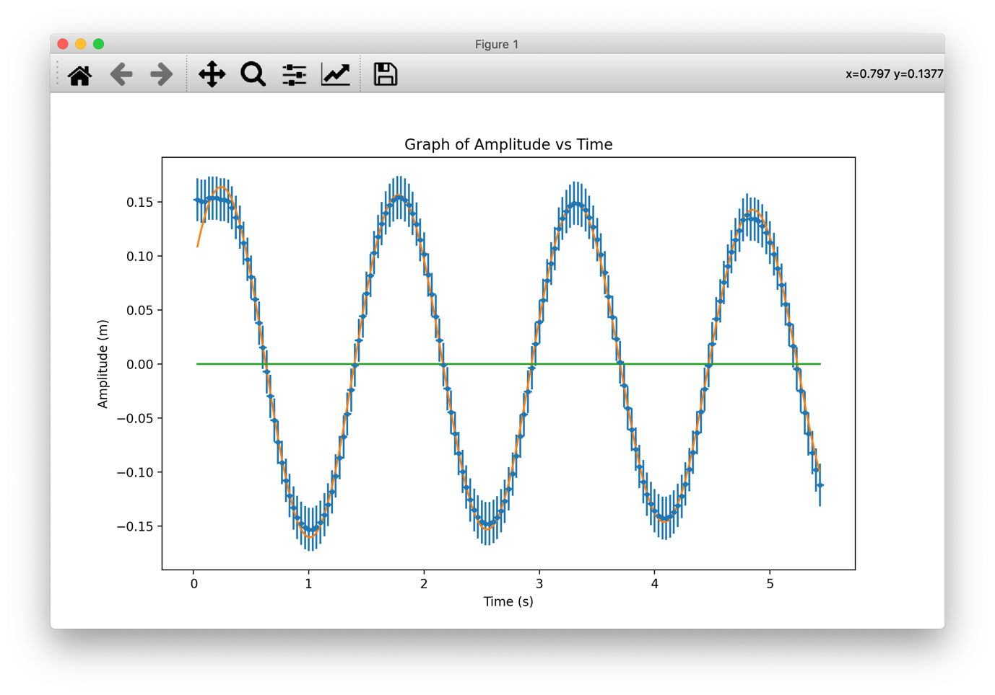

Figure 4 Graph of Amplitude vs Time from Python Script (First 5 Seconds)

The blue dots are data points that I collected and the orange graph represents the line of best fit. As you can see, the regression model of equation 1 is reflected in the data as the amplitude decays exponentially in Figure 2.

Figure 3 is a significantly more focused graph that looks at the first 5 seconds. This graph shows the significance of the tracker uncertainty as the error bars are significant compared to the time uncertainty.

Although I do not know how tau and the period were found by the Python program, by following the convention of using percent uncertainty, I am able to apply the tracker uncertainty to equation 1. Since the Python program used the initial amplitude to formulate the line of best fit, I found the percent uncertainty of ± 2 cm for 15.22 cm. That result being ~13%. Since the tracker uncertainty is the greatest uncertainty, I used it for the final value of Q.

$$τ=60±2$$

$$T= 1.5029±0.0002 (\frac{s}{cycle})$$

$$Q=\frac{πτ}{T}$$

$$Q=\frac{π\left(60±2\right)}{1.5029±0.0002}$$

$$Q=\frac{π\left(60±3.33\%\right)}{1.5029±0.0133\%}$$

*Use tracker uncertainty

$$Q=125.42±13\%$$

$$Q=130±20$$

## Conclusion

For method 1, Q was determined to be 130 ± 40. For method 2, Q was determined to be 130 ± 20. The Q value from each method agree with each other and lie within each other’s degrees of uncertainty. Since method 2 is based on values derived from the line of best fit, its smaller uncertainty makes sense as the values are more consistent. On the other hand, method 1 relied more heavily on recorded values and instruments. The effect of the tracker uncertainty was greater as the values of method 1 relied directly on the tracker values.

According to my data, Q can be as little as 90 or as large as 170. Since method 1 showed that it takes at least 90 oscillations to reduce the amplitude to about 46% of the original amplitude, I believe that my pendulum is sufficient to take the period by timing multiple oscillations. However, I will need improve my experimental setup as explained in the error analysis section to reduce the tracker uncertainty which could be significant when determining the period.

Appendix

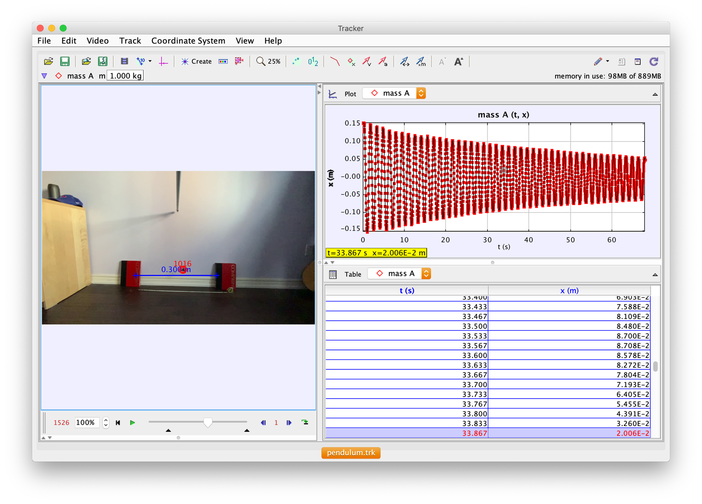

Figure 5 Tracker Software Used to Record Data

Raw Data Including:

* Python code
* Tracker data

<https://github.com/Jonathan-Woo/Pendulum-Labs.git>

References

[1] Wilson, B. (2020). PHY180 Lab Project (2020) [Class Handout]. Faculty of Applied Science and Engineering, University of Toronto, Toronto, ON.